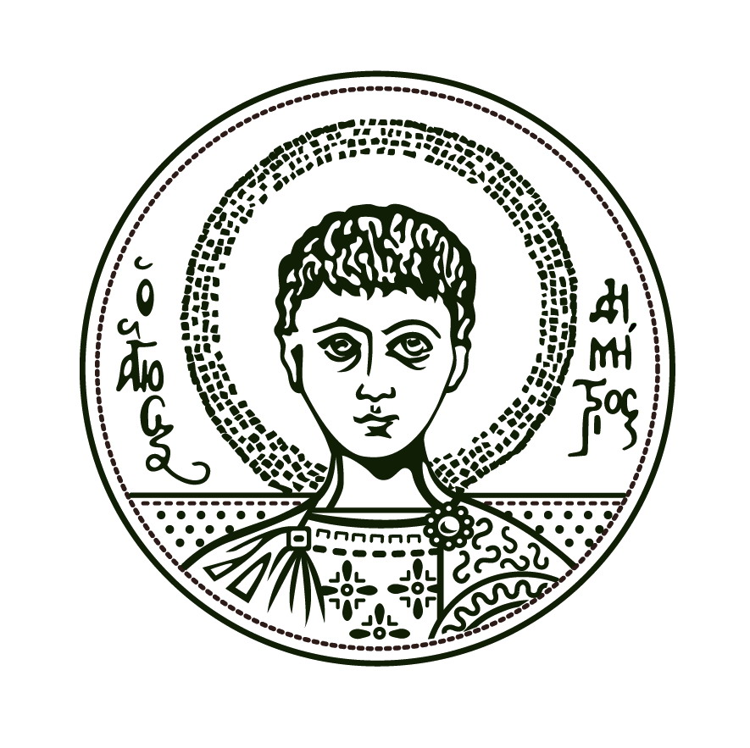HELLENIC REPUBLIC

ARISTOTLE UNIVERSITY OF THESSALONIKI
FACULTY OF ECONOMICS AND POLITICAL SCIENCES
SCHOOL OF POLITICAL SCIENCES

GREECE TODAY

AN INTRODUCTION TO THE POLITICS, SOCIETY AND ECONOMY IN CONTEMPORARY GREECE

Coordinator: Ioannis Papageorgiou, Asst. Professor
ECTS credits: 3
Time and place: Room 107, 1st floor Law School building, Wednesday 15-18.00
Course starts on Wednesday 14 October 2015

This is a course, composed by a series of lectures by staff members, doctoral and post-doctoral students of the School of Political Sciences. Its objective is to provide Erasmus and exchange students with an insight into – and the underlying causes of – the political, economic and social situation of Greece today. The lectures aim to introduce students to the most important aspects of Greek politics and the Hellenic society, as well as to offer them relevant information on the history and evolution of Thessaloniki, the city they currently live. This is an open-enrollment course, open to all Erasmus and exchange students in the Aristotle University of Thessaloniki; successful candidates receive three (3) ECTS credits.

All lectures will take place in room 107 (1st floor Law, Economic and Political Sciences building). Students should enroll by email to the course coordinator (ipapageo@polsci.auth.gr) by October 10, 2015, at the latest. Students should add the course in their learning agreement.

The lectures schedule will be announced shortly. The first lecture will take place on Wednesday 14 October 2015.

Process Monitoring and Grading

Since the course is designed in the form of a series of thematic lectures, attendance is crucial. Students will be graded by attendance, participation in class and the preparation of a paper on one of the thematic areas agreed with the relevant speaker.

Thematic topics

An introduction to the modern political history of Greece
- From the civil war to the dictatorship
- Post-1974 history
The political system of Greece after 1974
- Party system
- Electoral system
- The cleavages in Greek politics
- The fragmentation of the political system as a consequence of the crisis
The political culture
- Modernism versus traditionalism
- A European or a Balkan state
- The role of Church
Greece and the European Union
- A historic perspective
- EMU and Greece
- The immigration/refugee crisis
The economy of Greece
- From an agricultural economy to the services
- The “borrowed” prosperity
- The impact of the economic crisis
An introduction to the history of Thessaloniki
- A multicultural city – a metropolis of the Balkans
- The role of the Jews
- The changes after the W.W. II
- Re-inventing Thessaloniki in the 21st century

The detailed plan of the courses will be provided to applicants.

